
Company
Logotype

Cone Beam Computed Tomography- Report



Porur Dental X-rays & CBCT

Patient Name : Mr. Prabhakar | Date of Report : 02.03.2024
Age/ Gender : 41 years/ Male | Region of Interest : CBCT Mandible
Referring doctor: Dr. H. S. Ramlal Joshi | Indication : I.A.Nerve proximity in right side
Clinical Notes: Nil
PATIENT INFORMATION

CBCT- Mandible provided
CBCT – IMAGE DETAILS

RADIOGRAPHIC INTERPRETATION

- No of teeth present in the lower arch : 16
- The long axis of 48 appears to be parallel to the long axis of the adjacent 47 tooth.
- The crown of 48 is present partially within the ascending ramus of mandible.
- Distance between the mesial root of 48 and the Inferior Alveolar Nerve canal: 2.27 mm
- Distance between the distal root of 48 and the Inferior Alveolar Nerve canal: in contact.
- Kindly note that there is a small accessory nerve branch, running distal to the tooth 48 at a distance of 5.8 mm from the distal surface of 48.

RADIOGRAPHIC IMPRESSION

- Partially impacted tooth: 48

Kindly correlate with clinical findings


IMAGES FOR REFERENCE

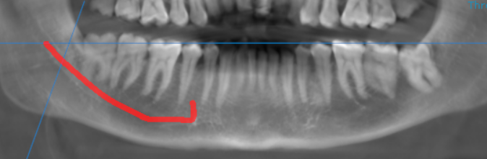

3-DIMENSIONAL VIEW

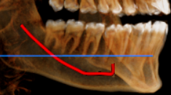

CROSS SECTIONAL VIEW

38 region- distal root in contact with the inferior alveolar nerve canal | 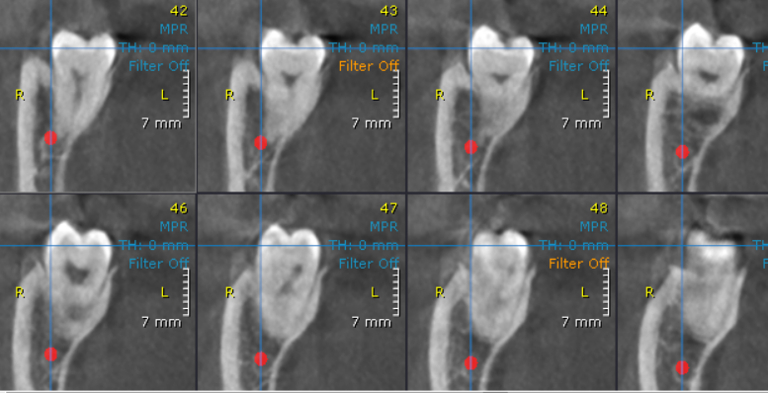

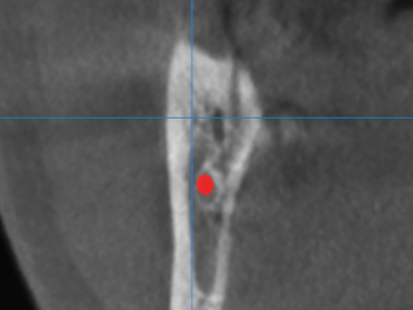

Accessory nerve branch distal to 48.

**** End of report ****

